Bioc 404: February 8th NTC

Dr. Galley began the lecture reviewing the specialized chromophore, Green Fluorescent Protein. This molecule is a probe that can be genetically engineered into a variety of systems. Its fluorescence comes about as a result of protein folding and the interaction between tyrosine and serine residues. When this molecule is excited, it delocalizes the electrons around these side chains, and the absorption gets shifted out into the visible and the emission in the green.

Influence of molecular motion on spectroscopy: By looking at p-nitrophenol upon protonation and deprotonation, we reviewed how different types of spectroscopy (notably electron absorption and NMR) have different properties, which determines the type of information one obtains.

The time scale of electronic absorption transitions are very fast, and in the order of 10⁻¹⁵ seconds whereas the timescale for NMR is much slower. Therefore, since comparatively the transition times in NMR are very slow, you see the influences of molecular motion, including actual chemical exchange, like the proton coming on and off in p-nitrophenol. However, in electron absorption spectroscopy this proton exchange does not impact the spectrum because the transition occurs so rapidly, and the Franck-Condon Principle is applied.

When you look at a solution of p-nitrophenol where the pH=pKa, 50% of the molecules are in the acid form and 50% are in the basic form.

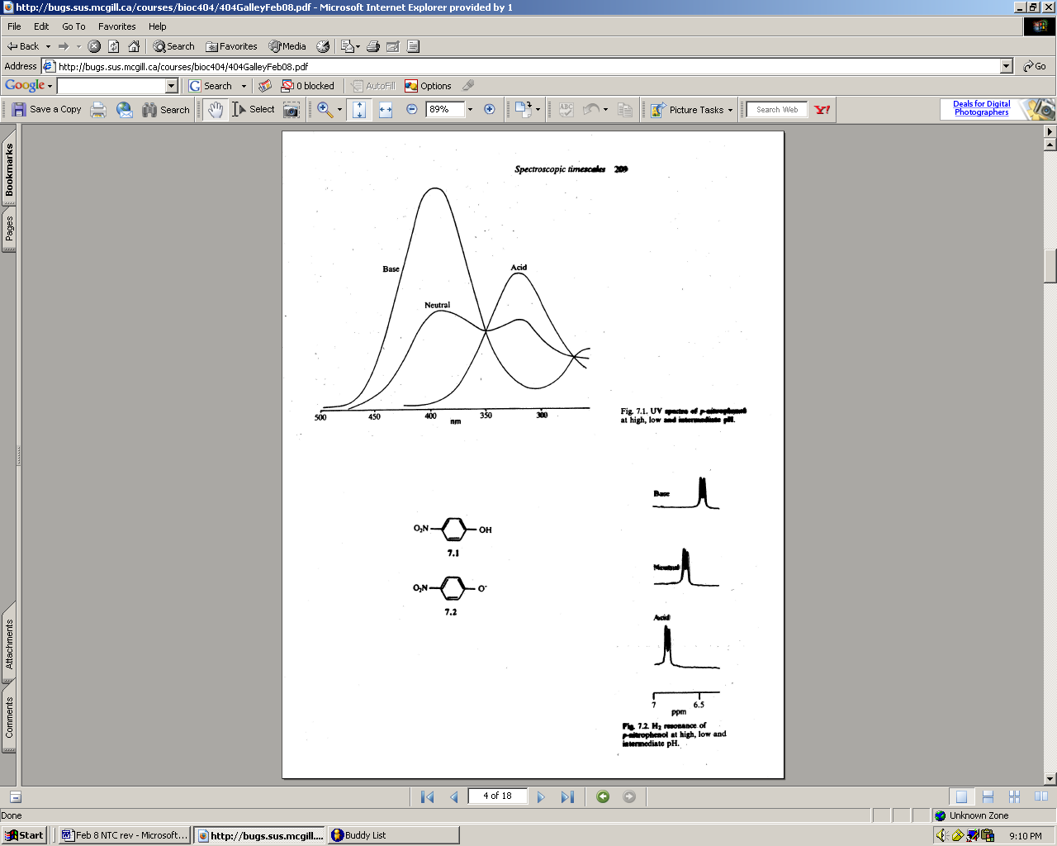
Electron Absorbance Spectroscopy: p-nitrophenol, when in its basic form absorbs at about 400 nm where as the acid form absorbs at around 320 nm. Therefore, a neutral solution will give a spectrum that has two peak absorbancies, one at 400 nm and one at 320 nm.

NMR: Remember that in this solution, there is fast exchange of the proton taking place, and since the NMR timescale for electronic transitions is much slower, the system gets confused, and the spectrum shows absorption at an intermediate value between that for the acid and basic forms. Specifically, for an NMR spectrum of basic p-nitrophenol, the absorbance is at around 6.5 ppm whereas the acidic form is at 6.9 ppm. The spectrum for the neutral solution is around 6.7 ppm. The main point is that there are all kinds of influences of dynamic molecular motions in both electron spin resonance and NMR that are not present in electron absorption due to the Franck-Condon principle.

Influence of local environment on absorption spectrum: If we analyze a molecule in its gas phase, it has a certain absorption frequency due to the energy difference between the grounded and the excited state, but this spectrum will change depending on the local environment of the molecule. Remember that the frequency of the absorption is related to the energy difference between the ground state and the excited state; therefore, when the energy difference is greater, the wavelength at which is absorbs is smaller and when the energy difference decreases, the wavelength of absorption is larger.

Case 1: Solvent that is polar but not polarizable (water)

When a molecule is in a polar solvent, both the sample molecule and the solvent molecule have a permanent dipole moment. As a result, the solvent molecule aligns itself favorably around the sample molecule. Therefore, the ground state has a lower energy due to favorable alignment of the solvent dipole around the chromophore. Now an electron is excited, and the Franck-Condon principle states that the nuclei in the molecule do not move because the transition is so fast. In general, the dipole moments of the chromophore in the excited state are larger because the electron is promoted to the antibonding state and the charge separation is greater. Therefore, the dipole moment is larger and in a different orientation; however, the transition was so fast that the solvent molecules remain in the same orientation from the ground state While the interactions between the solvent and the chromophore were favorable in the ground state they are not favorable in the excited state (the energy at excitation is therefore larger). Finally, due to the lower energy of the ground state and the higher energy of the excited state, the overall change in energy is greater, resulting in a blue shift. It is a blue shift because the wavelength of absorption is smaller (shifted to the blue part of the spectrum).

Case 2: Solvent that is polarizable but not polar (benzene or carbon tetrachloride)
In this, the solvent no longer has a permanent dipole moment; therefore, solvation involves the interaction between the dipole moment of the molecule and the induced dipole in the solvent. Again, the ground state is lower because the induced dipole of the solvent and the permanent dipole moment of the molecule are favorably interacting. Now we excite the electron and again the dipole moment gets larger and changes its orientation. However, because the solvent dipoles were induced dipoles (from distorting the electron cloud), when the dipole moment of the molecule changes orienation so does the induced dipole. This does not involve changing the orientation of the solvent molecule, it is just a distortion in the electron cloud. Therefore, the solvent molecules and the chromophore are interacting favorably in the excited state as well, thus lowering the energy of the excited state. The difference in energy compared to the gas phase is lower, resulting in a red shift. Therefore, nonpolar solvents tend to induce a red shift.

These properties of solvent-chromophore interaction can then be used to probe the local environments of chromophores in biological systems.

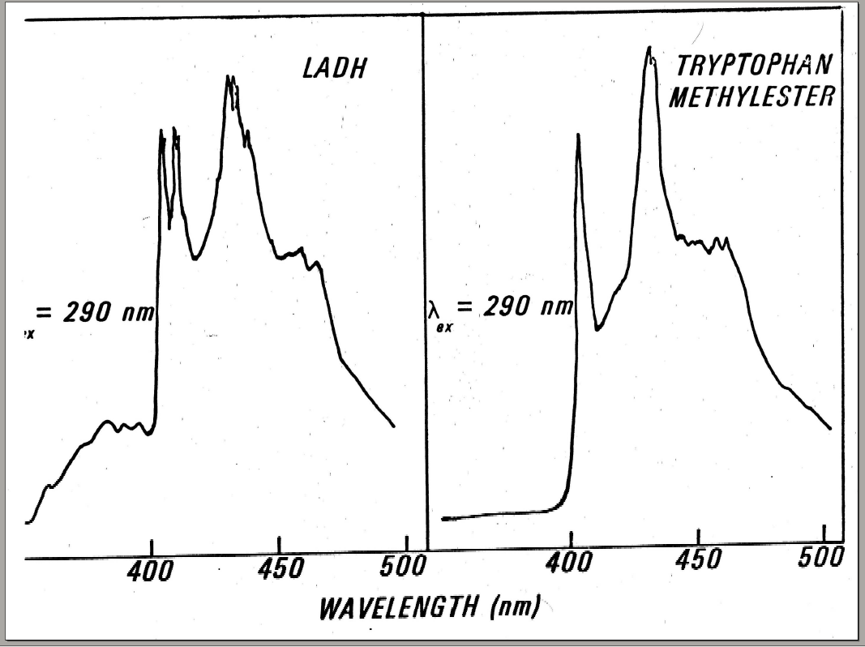
The phosphorescence spectrum-emission of alcohol dehydrogenase and tryptophan methylester in a water-glycol buffer mixture: Both spectrums have a peak at 400-405 nm for a tryptophan residue as well as a peak at 425-430 nm for a tyrosine residue. The phosphorescent spectrum of tryptophan methylester shows a single peak at 400-405 nm; however the phosphorescent spectrum for alcohol dehydrogenase has two sharp peaks at 400-405 nm. Why? Alcohol dehyrogenase is a dimer molecule with two tryptophan residues in each monomer. The presence of two peaks indicates that these two tryptophan residues are in different local environments and their respective interactions in these environments has caused a shift to occur, resulting in two peaks.

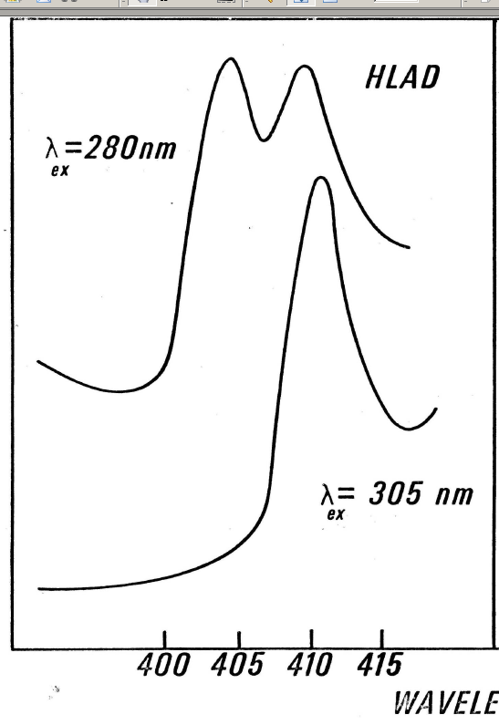
Line of evidence that these peaks correspond to different tryptophans: if one excites alcohol dehydrogenase at 280 nm, the tyrosine disappears because it is no longer excited; however, there are still two peaks corresponding to the two tryptophan residues. If the excitation wavelength is advanced to 305 nm there is only one peak, corresponding to one of the tryptophan residues because the other is no longer excited. This demonstrates how the absorption spectra are different not only for the tyrosine but also for the two tryptophans and that you can excite each independently of the other. You can then conclude that, since this molecule is in a water buffer, the blue shifted peak corresponds to a tryptophan that is interacting with the polar environment while the red-shifted peak corresponds to a tryptophan that is in the core of the protein.

You can see that at an excitation wavelength of 290 nm, all tryptophan and tyrosine residues are excited. As you increase the excitation wavelength, first you lose excitation of the tyrosine and then at 305 nm only one absorption peak remains, corresponding to the red-shifted tryptophan (because it is excited at a lower energy). Therefore, it is possible to decompose the absorption spectrum into the three components, demonstrating how the local environment affects the absorption spectra of this protein, alcohol dehydrogenase.

Fluorescence Spectra Shifts Depending on the Local Environment:

Phosphorescence shifts use the same principle as that of electron absorption spectroscopy where as the use of fluorescence as a probe of local environments happens in exactly the opposite way.

Fluorescence spectra of caltyrptin was analyzed in a variety of solvents using a methyl anthranilate probe: water, dioxane, and cyclohexane. You can see that the polar solvent, water gives a red-shifted spectrum, dioxane is intermediate, and cyclohexane is blue shifted.
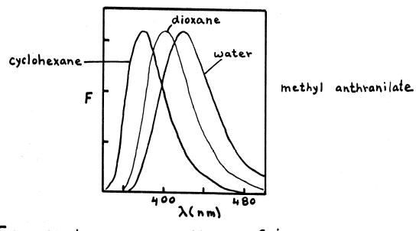
The idea is to make empirical correlations from what you see when this methyl anthranilate is coupled to an ester residue in caltryptin, and to decide what the local environment is. First, you need to understand why a fluorescent molecule in a polar solvent gives a red shift rather than the blue shift as seen with phosphorescence. The reason is simply that fluorescence has a larger excited state lifetime in comparison with electron absorption spectroscopy and phosphorescence. Given that the fluorescent molecule exists in the excited state a period of nanoseconds, the solvent molecules have time to align themselves favorably with the dipole moment of the excited molecule-a process called solvent relaxation. Therefore, in a polar environment, the solvent molecules are favorably aligned with the excited state chromophore, and this decreases the energy of the excited state. The Franck-Condon principle states that the molecule will then emit quickly, and when it is back to its groundstate orientation, the solvent molecules have not had time to realign themselves, thereby raising the groundstate energy level. This lower excited state energy level and higher groundstate energy level is a smaller overall energy difference, resulting in a red shift. This is a dynamic process; therefore, if you do time resolved nanosecond spectroscopy you can show that the spectrum shifts as a function of time so that when you initially excite the molecule, the spectrum is in fact shifted blue; however upon solvent relaxation it shifts to the red.

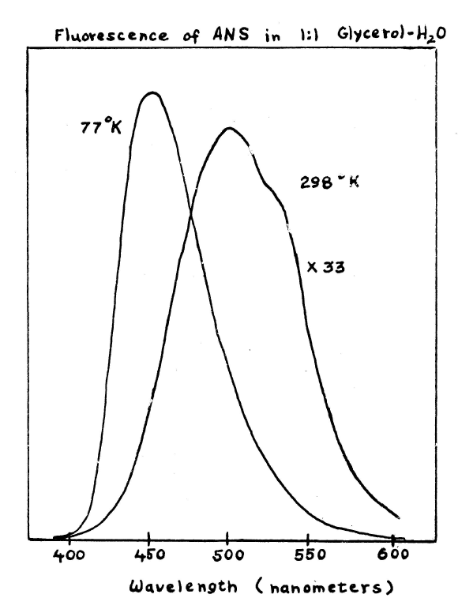
Solvent Relaxation Effects on Fluorescence of ANS (used for probing membranes): In nonpolar solvents, ANS is blue shifted and in polar solvents, there is a large red-shift with a decrease in the intensity of the fluorescence. To emphasize the fact that the red shift is a result of a dynamic process, solvent relaxation, Dr. Galley observed the fluorescence in a 1:1 mixture of glycerol and water at room temp where solvent relaxation takes place, and there is a peak at 525 nm. He then took the same mixture, excited it, and immediately cooled it in liquid nitrogen to observe the fluorescence. In this case, the solvent had solidified immediately after excitation; therefore, realignment of the solvent molecules could not take place and the spectrum showed a peak at 475 nm-it was shifted back to blue.

When you have a chromophore in a biomolecular structure, you must analyze the spectra with caution to determine the local environment. If it is blue shifted, you must determine if it is in a nonpolar environment or if it is in a polar environment that does not solvate the molecule (this might depend on the local viscosity of that region). The shifts in spectra also depend largely on the lifetime of the chromophore: if the lifetime is short there is not much time for relaxation to take place; however if the lifetime is very long, there is time for relaxation (for example, pyrene has an extremely long fluorescent life time of 100 ns)

Solvent Perturbation Spectroscopy: Again, for Electron Absorption Spectroscopy, nonpolar solvents induce red shifts; therefore, if you take a molecule and increase the polarizability of the solvent by adding sucrose or ethylene glycol then you will see a red shift. So if you have a protein, such as ribonuclease, which has tyrosine residues, and look at the absorption spectrum of that protein and compare that with the absorption spectrum of ribonuclease in a 20% sucrose buffer then you can detect that red shift.

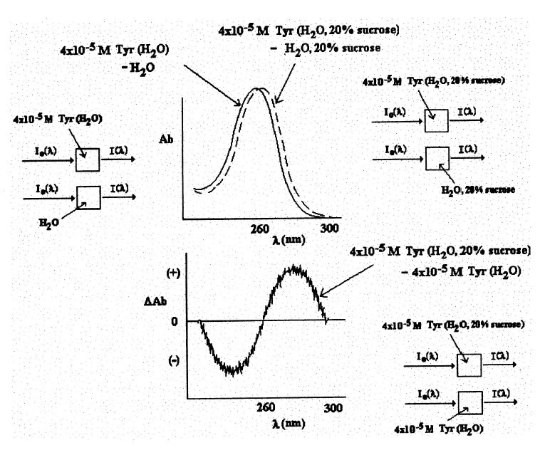
For simplicity, in the first example of solvent perturbation, we just look at a solution of 4E-5 M tyrosine: You run two spectra absorptions. In the first, you have 4E-5 M tyrosine in water against a reference sample of water and you get a spectrum. In the second step, you have 4E-5 M tyrosine in H₂0, 20% sucrose against a reference sample of H₂0, 20% sucrose and you plot the spectrum against the first. Then plot the difference between the two spectra (∆OD), and the difference is positive, indicating a red shift.

Solvent Perturbation and the Ribonuclease Spectra:
Solvent perturbation can also indicate different local environments, which can be seen with the protein, ribonuclease. This molecule has tyrosine molecules exposed to the polar H₂0 environment as well tyrosine molecules buried in the core of the protein.
When you change the environment to H₂0, 20% ethylene glycol, you see a red shift in the spectrum, but the magnitude is smaller than if all tyrosines were exposed. So you’re only seeing solvent perturbation by those tyrosines exposed while the ones that are buried do not shif. Therefore, conformational changes in the protein, which change the local environment of the residues, will show up quite readily in solvent perturbation spectroscopy.

Now, if you look at the spectra using 20% ethylene glycol, you see a red shift. However, if you use 80% ethylene glycol, you see a negative difference (∆OD) between the two spectra, indicating a blue shift. Interpretation is that you start out with two different spectrums: the exposed tyrosines in a polar environment and the buried tyrosines in a nonpolar environment. When you do a perturbation at 20% ethylene glycol, the buried tyrosines are unaffected, but the exposed ones are red shifted. However, when you put in 80% ethylene glycol then you shift the whole spectrum back to blue because the protein has been denatured, and those previously buried residues are now all exposed.

Linear Dichroism:

Since electronic absorbance has an orientation associated with it, one can use polarized light to probe aspects of the structures that exhibit this orientation dependence. This arises because when electrons are excited from ground to excited state there is directional dependence and a so-called changing dipole moment (transition dipole) that is required to see the absorption to begin with. This transition dipole has an orientation to it.
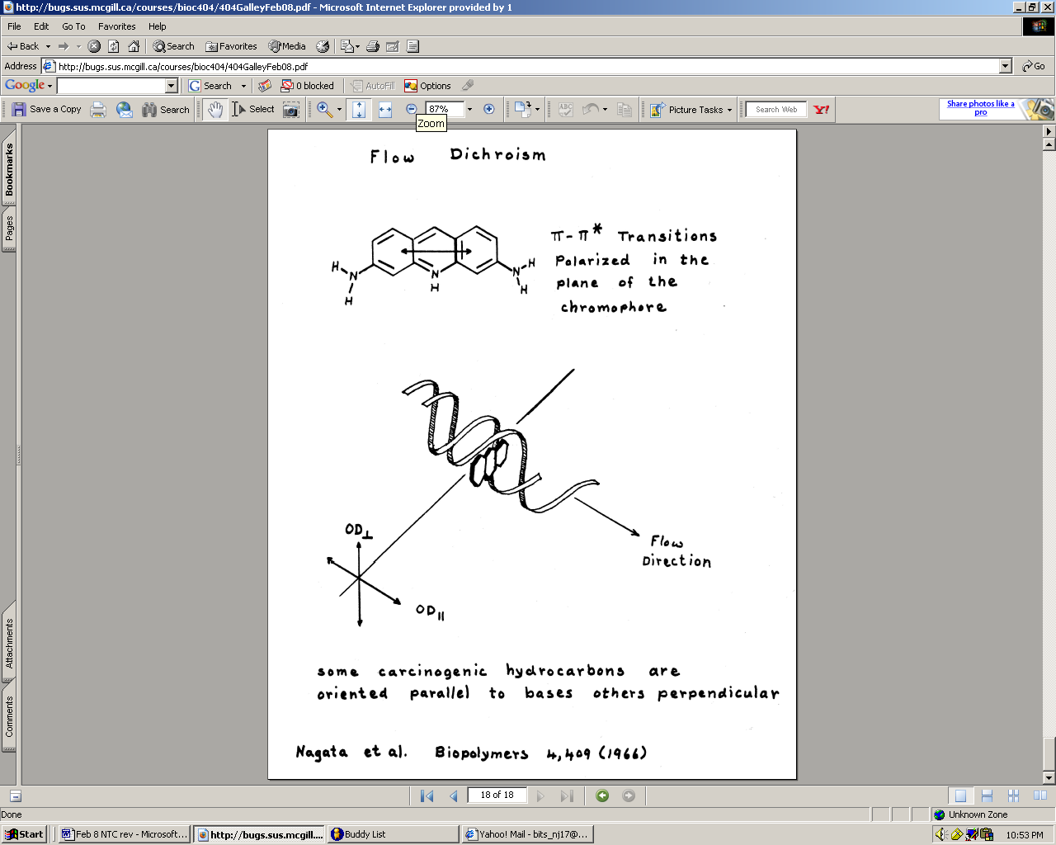
For π π* transitions the transition dipole moment is always in the plane (especially aromatic systems) and if you have a sufficient amount of symmetry it would have to be along the bond direction (represented as a double headed arrow because the electric field is in both directions)

In the case of adenine, you know the transition dipole moment will be in the plane of the molecule due to the π π* transition and that it is aromatic. That in itself can be useful because you can carry out experiments with DNA and look at the polarization, also called the linear dichroism. This occurs when you excite the sample with polarized radiation (using a film, filter, or prism) and you look at the absorption. Measure the absorbance using polarized light in both a vertical direction and a horizontal direction to get a dichroic ratio.

The dichroic ractio is defined as: A_{vert}-A_{horiz}
A_{vert}+A_{horiz}

If you look at a DNA sample in a conventional absorption cell in solution you find that the dichroic ratio equals zero. In this solution, all the molecules are randomly oriented; therefore their transition dipole moments are oriented along the vertical as well as along the horizontal. However, if you induce direction (by stretching a polymer film, subjecting it to flow, or using an electric field like in gel electrophoresis) then you would see a dichroic ratio that does not equal zero.

For example, if you are looking at DNA in a flow field (pulse gel system), when you excite the sample with polarized light in the vertical and horizontal (along the axis of the DNA) directions, the DNA will be preferentially excited in the vertical direction. This occurs because the vertical (perpendicular to the flow of the DNA) light is in the same plane as the bases; therefore, it is in the same plane as the transition dipole. They will be preferentially excited with the vertical radiation that is parallel to the bases, and the only component seen along the horizontal direction would be due to imperfect alignment.

